**ATHR Presents Basmah Felemban’s First Solo: Consecrated Networks**

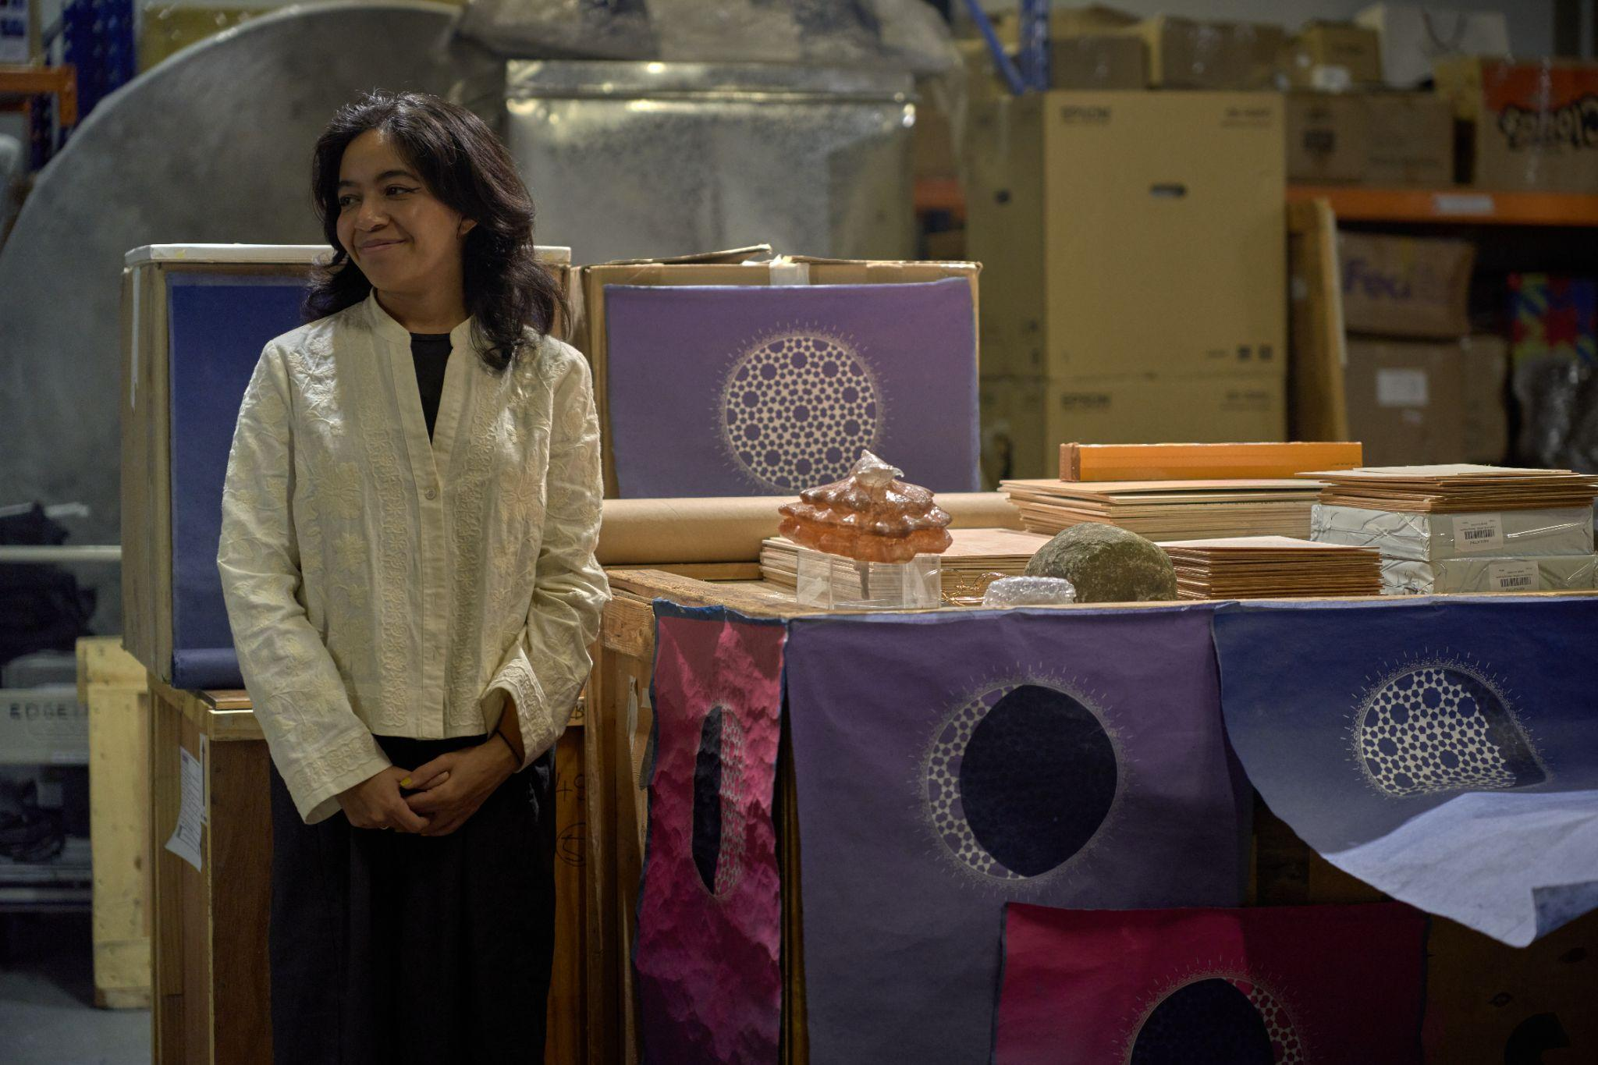

ATHR is pleased to announce Basmah Felemban’s first solo exhibition titled “Consecrated Networks”, curated by Ruba Al-Sweel. The exhibition is set to open on the 6th of March during ATHR’s 15-year anniversary event.

Inspired by the urban landscape of Jeddah, as well as the evolution of networked communications and data systems, “Consecrated Networks” presents across three gallery spaces a backlog of documentation, experimentation and supporting material that built her decade-long portfolio of multimedia, research-based works. Felemban translates our physical world through data exchange, using references from Islamic cosmology, architecture and pop culture. She manipulates language into form or lack of, such as using catfish for erasure, to guide a narrative that explores world-building, nostalgia, theology and larger geopolitical structures of migration.

This exhibit reveals how archives shape the future in an imaginative way. Felemban sees archives as a hidden memory bank, sometimes changed to fit new situations. She explores the creative potential of dreams and the subconscious in world-building. Felemban breaks down architecture to understand its symbolic significance and connections.

“Consecrated Networks” will be on display from March 6th until the end of May, 2024.

**About ATHR**

ATHR was founded in 2009 in Jeddah, Saudi Arabia, by Mohammed Hafiz and Hamza Serafi. From its onset it has been a pioneering gallery with global aspirations. We represent artists that have been the driving force of the gallery from the beginning and who have inspired our responsive mandate that evolves to accommodate the ever-changing local scene. We pride ourselves on being adaptive which has been a testament to our legacy that has spanned over a decade. Our diverse roster of artists work across multiple disciplines and subject matter from the more traditional such as painting and sculpture to more unconventional methods that echo the daring nature of the gallery. The subject matter they address also vary wildly covering a spectrum of narratives that vary from the personal scale to the macro-cultural. ATHR has expanded in the kingdom with three locations besides the original space; ATHR AlUla is the first contemporary art gallery in the historical city, and our newest outpost is ATHR JAX, an important space in Riyadh, which is the capital of Saudi Arabia and an important art hub in the region. The opening of our Riyadh location is a long-awaited location expansion for ATHR beyond the western region of the kingdom. With our growth to the various outposts in the kingdom, the Jeddah location remains the largest space and continues to be the ATHR headquarters.

**ABOUT BASMAH FELEMBAN**

Basmah Felemban is an emerging artist whose skills as a self-taught graphic designer invest her practice with a distinctly contemporary digital edge. Felemban’s artworks range in medium from drawing, sculpture, digital animation and coding. Within her practice Felemban creates wildly imaginative cosmological works in game form. Felemban is a builder of worlds, contrived of characters and environments that wittily combine diverse inspirations, including impossible mathematical forms and game theory. The artist’s practice, while seemingly chiefly concerned with the technologies of the present and their innovative possibilities, is simultaneously anchored in the traditions of previous artistic forms making hers a uniquely dynamic and positively challenging opus. She received an MFA in Traditional and Islamic Art from The Prince’s School of Traditional Arts in London, where she focused on 12th-14th century Islamic manuscripts, with a specific interest in those that discussed cosmographies, mythical creatures and cartography.

This research gave a historical backing to her own projects, sculptures and installations, which likewise depict traditional Arab and Muslim cosmogonies and illuminate esoteric meanings in literature, poetry, numerology, and Islamic art. Her current practice explores worldbuilding as a method to understand the mysteries in her family history, the role of imagination in rewriting identity, and the ways humans have resorted to bridging gaps in collective memory.

Collaboration is also key for Felemban, she is constantly generating opportunities for connection in her works. A major community project is Saudi Street Art, an online platform which encourages the public to focus their attention on the expressive art found on their city walls, as a means to better understand the younger generation’s concerns and interests.

**ABOUT RUBA AL-SWEEL**

Ruba Al-Sweel is a multidisciplinary creative with a practice rooted in writing and research focused on media theory and networked communications. She has published in journals, magazines and books, and is the co-editor of POSTPOSTPOST, an annual publication of cultural critique. Her work has appeared in the Brooklyn Rail, Art Asia Pacific, VICE, DoNotResearch among others. She curates exhibitions in Dubai, Berlin, Paris, Jeddah and online. She holds a master’s degree in media and creative industries from SciencesPo, Paris.